DAT601
Declan Dover

Assessment 1 Part 2
Conceptual Database Design

1. Introduction to Data Modelling 4
1.1. Data Modelling in Information Systems 4
1.2. Relationships Between Conceptual, Logical, and Physical Stages 4
1.2.1. Conceptual 4
1.2.2. Logical 5
1.2.3. Physical 5
2. Description of Conceptual Modelling 5
2.1. Application of Extended Chen ERD 5
2.2. Entities 5
2.2.1. Strong Entities 6
2.2.2. Weak Entities 6
2.3. Attributes 6
2.3.1. Simple Attributes 7
2.3.2. Composite Attributes 7
2.3.3. Multi-Valued Attributes 7
2.3.4. Derived Attributes 8
2.4. Candidate Keys 8
2.5. Relationships 9
2.5.1. Cardinality 9
2.5.2. One-to-one 9
2.5.3. One-to-many 9
2.5.4. Many-to-many 10
2.5.5. Participation 10
2.5.6. Strong Relationships 10
2.5.7. Identifying Relationships 11
3. Conceptual ER Model 11
3.1. Conceptual ER Model 13
3.2. Rationale 14
3.2.1. Entities 14
3.2.2. Relationships 14
3.2.4. Other Design Decisions 16
4. Data Dictionary 17
4.1. Entities 17
4.2. Relationships 19
4.3. Attributes 20
4.4. Rationale 33
Entities 33
Relationships 33
Attributes 33
5. Business Rules 34
5.1. Business Rules 34
Business Rules 34
Assumptions 35
Justification 35
6. Conclusion 36
7. References 36

1. Introduction to Data Modelling

1.1. Data Modelling in Information Systems

Data modelling is the creation of visual representations of the data in a system. It is used to illustrate the types of data within a system, the relationships between the data, the different ways in which it can be grouped and organised, and the different attributes belonging to each type of data (What Is Data Modeling?, 2021). The use of this modelling helps us to understand database structure and design, which enables proper management of the data and enables organisations to turn that data into usable knowledge and information.

1.2. Relationships Between Conceptual, Logical, and Physical Stages

Conceptual, logical, and physical diagrams are three different ways of modelling data. Each model focuses on a different audience and a different perspective on the data within a system (Conceptual, Logical and Physical Data Model, n.d.). In a typical design process the modelling would take in place in the order:

Conceptual → Logical → Physical

1.2.1. Conceptual

The conceptual model is a high level visualisation of the database that is independent of physical considerations. It is used to find out what data exists within a system rather than how the data will be stored.

1.2.2. Logical

The logical model is a more structured form of the data from the conceptual model, converting entities into tables, attributes into columns, and starting to describe relationships using primary and foreign keys. Normalisation is usually applied at this stage.

1.2.3. Physical

The physical model takes the logical model and applies it to specific hardware or a DBMS. Things like performance and security that are not part of the logical model are considered at the physical stage.

2. Description of Conceptual Modelling

2.1. Application of Extended Chen ERD

Extended CHEN notation is a conceptual model used for modelling the data requirements of a system. This model allows for real world entities and systems to be visualised in a way that can be used as a basis for a future logical model. The different parts of CHEN notation are as follows:

2.2. Entities

An entity represents an object or concept that a system needs to store data about. Each entity needs to be uniquely identifiable meaning no 2 entities can be identical in all their attributes (Athuraliya, 2025). The extended Chen ERD we will be using for this project has 2 types of entities:

2.2.1. Strong Entities

A strong entity is an entity that can exist on its own, and does not rely on another entity to identify it. A strong entity is depicted by a solid rectangle containing its name.

Depiction:

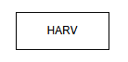

2.2.2. Weak Entities

A weak entity is an entity that is dependent on a related strong entity for part of its identity. A weak entity can’t exist without its related strong entity. A weak entity is depicted by a double rectangle containing its name.

Depiction:

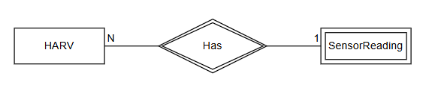

2.3. Attributes

Attributes describe the properties or characteristics of an entity or relationship. They help to define the details about entities or relationships and to distinguish between instances. Extended Chen ERD has four types of attributes:

2.3.1. Simple Attributes

A simple attribute holds a single value. It is depicted by a solid oval containing the name of the attribute.

Depiction:

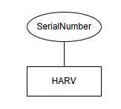

2.3.2. Composite Attributes

A composite attribute is an attribute that has its own sub-attributes. It is depicted as an oval with other ovals connected to it, containing the names of the sub-attributes.

Depiction:

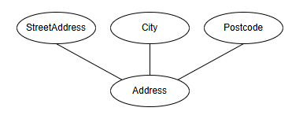

2.3.3. Multi-Valued Attributes

A multi-valued attribute is an attribute that can hold more than one value for a single entity. It is depicted by a double oval containing the attributes name.

Depiction:

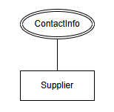

2.3.4. Derived Attributes

A derived attribute is an attribute that’s value can be calculated using other data within the system. It is depicted as a dashed oval containing the attributes name.

Depiction:

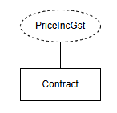

2.4. Candidate Keys

A candidate key is an attribute or set of attributes that can be used to uniquely identify an instance of an entity. A candidate key is depicted by underlining the name of an attribute, or multiple attributes, connected to an entity.

Depiction:

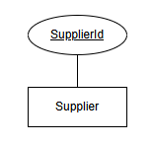

2.5. Relationships

A relationship represents an association between entities in a database. Relationships are described by the verbs that link entities. Relationships are depicted with lines connecting them to the entities. These connecting lines can also depict properties of the relationship. These properties are:

2.5.1. Cardinality

The cardinality of a relationship defines the number of each relationship that an entity instance can have. Three types of cardinality can be represented:

2.5.2. One-to-one

A one-to-one relationship is where each instance of an entity can only have one relationship of that type. It is depicted with a 1 at the beginning of the line joining an entity to a relationship.

Depiction:

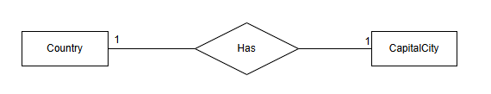

2.5.3. One-to-many

A one-to-many relationship is where the first entity instance can have relationships with many instances of the second entity, but an instance of the second entity can have only one relationship with an instance of the first entity. It is depicted with a 1 by the entity that can have many relationships and a N beside the entity that can have only one of that relationship.

Depiction:

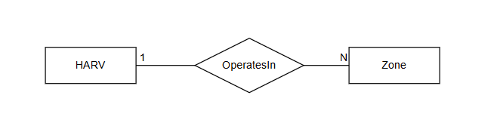

2.5.4. Many-to-many

A many-to-many relationship is where an instance of each entity in that relationship can have many of those relationships. It is depicted with an M beside one entity and an N beside the other.

Depiction:

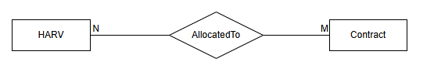

2.5.5. Participation

Participation in a relationship defines whether the relationship is mandatory or optional for an entity. Total participation, meaning that each instance of an entity must participate in that relationship, is represented by a double line. Partial participation, meaning each instance of an entity may or may not participate in that relationship, is depicted with a single line.

Depiction:

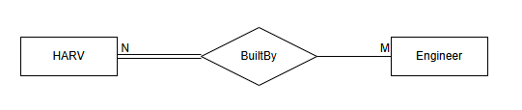

2.5.6. Strong Relationships

A strong relationship is a relationship between entities that can exist independently from other entities. Strong relationships are depicted by a solid diamond containing a description of the relationship.

Depiction:



2.5.7. Identifying Relationships

An identifying relationship is a relationship between a strong entity and one of its associated weak entities, described above. This is the relationship which the weak entity is dependent on for part of its identity. It is depicted by a double diamond containing a description of the relationship.

Depiction:

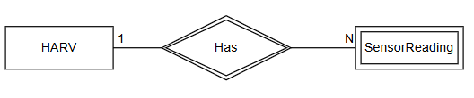

3. Conceptual ER Model

3.1. Conceptual ER Model
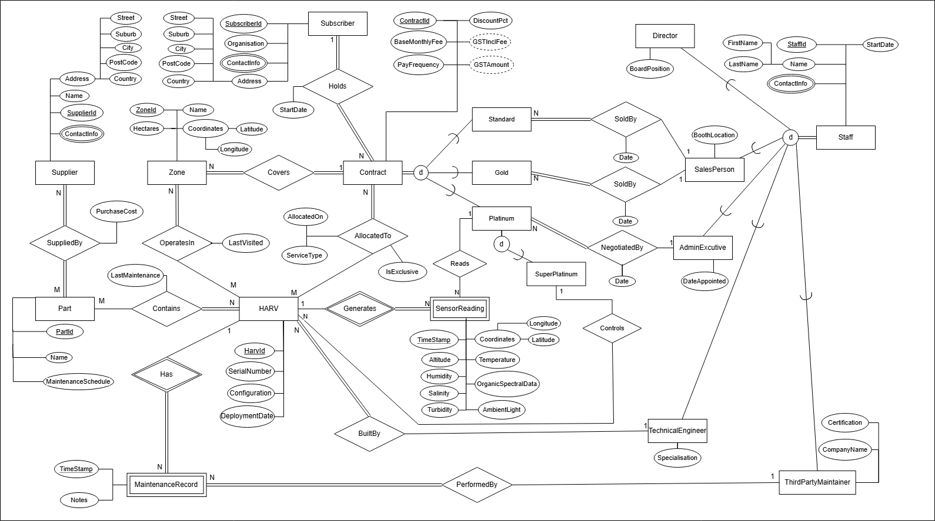

3.2. Rationale

3.2.1. Entities

HARV, Subscriber, Contract, Zone, Staff, Part, and Supplier are all strong entities within my model because they can exist independently of any other entity in the system, however, there are two weak entities in the model, SensorReading, which cannot exist without the HARV that collected the reading, and MaintenanceRecord, which cannot exist without the HARV for which this is a record of maintenance upon.

The staff entity exists in my model as a supertype with total disjoint separation into 5 subtypes, which are the 5 roles described in the project brief. This is because my model makes the assumption that all staff must be one of these set roles, and they cannot hold multiple of these roles.

The contract entity also exists as a supertype within my model. Each contract must be either a standard, gold, or platinum subscription. Each of these subtypes has their own relationships. The platinum subtype is also a supertype, and a partial disjoint relationship connects it to the ‘SuperPlatinum’ Entity. This partial disjoint means a platinum subscription can be a superplatinum subscription but does not have to be. This is because the project brief states that a super platinum subscription is a type of platinum subscription.

All the entities within the model have the relevant attributes needed to describe them and hold relevant information for the company. Each entity has an attribute or combination of attributes that can be used to uniquely identify them. Weak entities have an attribute that can be used in combination with the identifier of the strong entity to uniquely identify them. These are the timestamp attributes on SensorReading and MaintenanceRecord, which in combination with the HarvId of the HARV entity they are dependent on can be used to uniquely identify them.

3.2.2. Relationships

The ‘Holds’ relationship between Subscriber and Contract in model is a 1 to many relationship, with total participation on both sides, as a subscriber can hold many relationships, and must hold at least one to have a purpose within the system, while a contract must be held by exactly 1 subscriber. The same is true for the ‘Covers’ relationship between Contract and Zone, as a Contract must cover at least 1 zone, and a zone must be covered by only one contract for it to have a reason to exist within the system.

The BuiltBy relationship between HARV and TechnicalEngineer is a many to 1 relationship, with total participation on the side of the HARV. This is because all HARVs were built by a technical engineer, but a technical engineer may have built more than one HARV, or may not have built any HARVs yet. The performedBy relationship between MaintenanceRecord and ThirdPartyMaintainer follows the same structure, as a maintenance record must have a single third party maintainer it was performed by, but a third party maintainer could have performed none or multiple maintenance records.

My model contains two identifying relationships, both owned by the HARV entity. These relationships are for the two weak entities in the model, SensorReading and MaintenanceRecord. This is because these weak entities cannot exist without a relationship to their HARV.

My model contains four many-to-many relationships. The first is SuppliedBy which is between Supplier and Part. This relationship has total participation on both sides because a supplier must supply at least one part to have a reason to exist within the system, and a part must have a supplier that supplies it. It is a many to many because a part could be supplied by multiple suppliers and a supplier can supply multiple different parts. The second many-to-many relationship is Contains, which is between Part and HARV, with total participation on the side of the HARV. This is because multiple HARVS can use the same parts, and a HARV must contain at least one part in order to exist. The third and fourth many-to-many relationships are OperatesIn, which is between HARV and Zone, and AllocatedTo, between HARV and Contract. These relationships are many to many because a contract or zone can have many HARVs assigned to them, and a HARV can be assigned to many contracts or zones. Both of these relationships have total participation on the side of Contract and Zone because a Zone or Contract with no HARVs assigned to them have no reason to exist within the system.

As well as the BuiltBy relationship described earlier, my model also contains three other one-to-many, total to partial relationships. The first two of these are between the salesperson entity and the standard and gold subscription subtypes of the contract entity.. The next one-to-many is between AdminExecutive and a platinum subtype of the Contract entity. This relationship is based on the same assumption as the previous relationships as it is stated in the project brief that platinum subscriptions are negotiated not by salespeople but by admin executive staff. All of these three relationships have total participation on the side of the contract subtype, as for a contract to be created it must have been sold or negotiated by an employee, and partial participation on the respective employee’s side, as these salespeople or admin executive may have yet to negotiate or sell a contract.

The model also contains two one-to-many, partial to partial relationships. The first of these is the ‘Controls’ relationship between a superplatinum contract and a HARV. This relationship has partial participation on both sides as exclusive control of a HARV is an optional feature of the contract. This relationship also states that one HARV can only be exclusively controlled by a single contract, implied by the term exclusive. The second of these is the ‘Reads’ relationship between SuperPlatinum and SensorReading. This relationship assumes that a sensor reading can be read by only one subscription, but can also be read by no subscriptions, and that a subscription could read many sensor readings but also none.

Some relationships have attributes that are used to further describe a specific relationship. These attributes are PurchaseCost, describing the cost of a part supplied by a supplier in the SuppliedBy relationship, LastMaintenance, describing the last time a part underwent maintenance that is part of the Contains relationship between HARV and Part, and LastVisited, describing the last time a HARV visited a zone as part of an OperatesIn relationship. All SoldBy relationships between a contract and a member of staff have a Date attribute that contains the date that contract was sold. The AllocatedTo relationship between HARV and contract has three attributes, IsExclusive which describes whether a HARV is exclusive to a contract, AllocatedOn which is the date a HARV was allocated to a contract, and ServiceType, which describes the service the HARV is allocated to perform.

3.2.4. Other Design Decisions

Partial participation is applied from the HARV side of the ‘OperatesIn’ relationship as a HARV can exist within the system and not be deployed to a zone. Total participation is applied from the Zone side as a zone must have at least one HARV operating within it or it has no reason to exist within the system.

Part is modelled as a part type rather than a specific physical instance of a part. The same part type may be installed across many HARVs, and each HARV contains many part types. The HARV–Part relationship tracks LastMaintenanceDate per HARV per part type.

The SensorReading entity uses only one attribute for its altitude and depth. This is because a negative altitude reading can be used as the HARVs depth reading.

4. Data Dictionary

4.1. Entities

Entity Name | Description | Aliases | Occurence
Subscriber | Represents a single instance of a customer that has subscribed to any contract type. | Customer, Client | When a new customer purchases a subscription.
Contract | Represents a single instance of a contract that a customer has subscribed to. | Subscription | When a new or existing customer makes a new subscription.
Standard | Represents a contract at the standard subscription level. | Standard Subscription, Standard Contract | When a new or existing customer purchases a standard subscription.
Gold | Represents a contract at the gold subscription level. | Gold Subscription,  Gold Contract | When a new or existing customer purchases a gold subscription.
Platinum | Represents a contract at the platinum subscription level. | Platinum Subscription,  Platinum Contract | When a new or existing customer purchases a platinum subscription.
SuperPlatinum | Represents a contract at the super platinum subscription level. | Super platinum Subscription,  Super platinum Contract | When a new or existing customer purchases a super platinum subscription.
Zone | Represents a zone that is included in a contract. | Operating Area | When a subscription is purchased any zones it will cover will be created as a zone instance.
HARV | Represents a single HARV drone. | Drone | When a HARV is built by a technical engineer a new HARV instance will be created.
Supplier | Represents a single supplier that supplies any HARV parts to the company. | Vendor | When a part is ordered from a supplier that does not already exist in the database a new supplier instance will be created.
Part | Represents a type of part that is included in one or more HARVs | Component | When a HARV is built any parts not already existing in the database will be added.
SensorReading | Represents a single sensor reading for a HARV at a specific point in time | Sensor data | A sensor reading is produced by HARVs that are assigned to a contract that gives subscribers access to HARV data
MaintenanceRecord | Represents the results of a maintenance task performed on a HARV | Maintenance Report | A third party maintainer will produce maintenance records when carrying out maintenance on a HARV
Staff | Represents a single company employee | Employee | Every company employee and third party contractor hired by the company will have a staff entry
Director | Represents a director of the company |  | A new or existing employee assigned the position of director
SalesPerson | Represents an employee with the role of sales person |  | A new or existing employee assigned the position of salesperson
AdminExecutive | Represents an employee with the role of administrative executive | Administrative Executive | A new or existing employee assigned the position of administrative executive
TechnicalEngineer | Represents an employee with the role of technical engineer | Engineer | A new or existing employee assigned the position of technical engineer
ThirdPartyMaintainer | Represents a third party engineer contracted to the company | Maintainer | A new or existing contractor hired to perform maintenance on HARVs

4.2. Relationships

Entity Name | Cardinality | Participation | Relationship | Participation | Cardinality | Entity Name
Subscriber | 1 | Total | Holds | Total | N | Contract
Zone | N | Total | Covers | Total | 1 | Contract
Contract | N | Total | AllocatedTo | Partial | M | HARV
HARV | M | Partial | OperatesIn | Total | N | Zone
HARV | N | Total | Contains | Partial | M | Part
HARV | 1 | Partial | Has | Total | N | MaintenanceRecord
HARV | N | Total | BuiltyBy | Partial | 1 | TechnicalEngineer
HARV | 1 | Partial | Generates | Total | N | SensorReading
Part | M | Total | SuppliedBy | Total | N | Supplier
Standard | N | Total | SoldBy | Partial | 1 | SalesPerson
Gold | N | Total | SoldBy | Partial | 1 | SalesPerson
Platinum | N | Total | NegotiatedBy | Partial | 1 | AdminExecutive
Platinum | 1 | Partial | Reads | Partial | N | SensorReading
SuperPlatinum | 1 | Partial | Controls | Partial | N | HARV
MaintenanceRecord | N | Total | PerformedBy | Partial | 1 | ThirdPartyMaintainer
Staff | Total |  | Specialisation | Disjoint |  | Director
 | Total |  | Specialisation | Disjoint |  | SalesPerson
 | Total |  | Specialisation | Disjoint |  | AdminExecutive
 | Total |  | Specialisation | Disjoint |  | TechnicalEngineer
 | Total |  | Specialisation | Disjoint |  | ThirdPartyMaintainer
Contract | Total |  | Specialisation | Disjoint |  | Standard
 | Total |  | Specialisation | Disjoint |  | Gold
 | Total |  | Specialisation | Disjoint |  | Platinum
Platinum | Partial |  | Specialisation | Disjoint |  | SuperPlatinum

4.3. Attributes

Entity Name | Attributes | Description | Domain | Aliases | Composite | Derived | Nulls | Key? | Default Value
Subscriber | SubscriberId | Unique Identifying number for a subscriber | INTEGER, auto-incremented |  | No | No | No | PK
 | Organisation | The organisation that the subscriber represents | VARCHAR(255) | Company | No | No | No | No
 | ContactInfo | A multivalued attribute containing a name, phone number, and/or email address | VARCHAR(255) |  | No | No | Yes | No
 | Address | A composite attribute for the subscribers address values; Street, Suburb, City, PostCode, Country | Street:  VARCHAR(255)  Suburb:  VARCHAR(255)  City:  VARCHAR(255)  Postcode:  VARCHAR(255)  City:  VARCHAR(255) |  | Yes | No | Yes | No

Entity Name | Attributes | Description | Domain | Aliases | Composite | Derived | Nulls | Key? | Default Value
Contract | ContractId | Unique Identifying number for a contract | INTEGER, auto-incremented |  | No | No | No | PK
 | BaseMonthlyFee | The base monthly fee before discount of the contract | DECIMAL(10,2) |  | No | No | No | No
 | PayFrequency | The pay frequency for the contract, monthly or yearly | VARCHAR(10) |  | No | No | No | No
 | DiscountPct | The applied discount for the contract, between 0 and 3 and represents a % discount | DECIMAL(5,2), 0.00–3.00 Between 0 and 3, represents a % discount |  | No | No | No | No
 | GSTInclFee | The fee after discounts and GST are applied | DECIMAL(10,2) |  | No | Yes | No | No
 | GSTAmount | The total GST amount of the contract fee | DECIMAL(10,2) |  | No | Yes | No | No

Entity Name | Attributes | Description | Domain | Aliases | Composite | Derived | Nulls | Key? | Default Value
Zone | ZoneId | Unique Identifying number for a zone | INTEGER, auto-incremented |  | No | No | No | PK
 | Name | The name of the zone | VARCHAR(255) |  | No | No | Yes | No
 | Hectares | The size of the zone in hectares | DECIMAL(10,2), positive |  | No | No | No | No
 | Coordinates | Composite attribute made up of a latitude and longitude representing the location of the zone | Latitude:  DECIMAL(8,6)  Longitude:  DECIMAL(9,6) |  | Yes | No | No | No

Entity Name | Attributes | Description | Domain | Aliases | Composite | Derived | Nulls | Key? | Default Value
HARV | HarvId | Unique Identifying number for a HARV | INTEGER, auto-incremented |  | No | No | No | PK
 | SerialNumber | The serial number for a HARV | VARCHAR(100) |  | No | No | No | Candidate Key
 | Configuration | The configuration of the HARV | VARCHAR(50) |  | No | No | No | No
 | DeploymentDate | The date the HARV was first deployed | DATE |  | No | No | Yes | No

Entity Name | Attributes | Description | Domain | Aliases | Composite | Derived | Nulls | Key? | Default Value
Supplier | SupplierId | Unique Identifying number for a supplier | INTEGER, auto-incremented |  | No | No | No | PK
 | Address | A composite attribute for the supplier’s address values; Street, Suburb, City, PostCode, Country | Street:  VARCHAR(255)  Suburb:  VARCHAR(255)  City:  VARCHAR(255)  Postcode:  VARCHAR(255)  City:  VARCHAR(255) |  | Yes | No | No | No
 | Name | The name of the supplier | VARCHAR(255) |  | No | No | No | No
 | ContactInfo | A multivalued attribute containing a name, phone number, and/or email address | VARCHAR(255) |  | No | No | Yes | No

Entity Name | Attributes | Description | Domain | Aliases | Composite | Derived | Nulls | Key? | Default Value
Part | PartId | Unique Identifying number for a part | INTEGER, auto-incremented |  | No | No | No | PK
 | Name | The name of the part | VARCHAR(255) |  | No | No | No | No
 | MaintenanceSchedule | The amount of years between scheduled maintenance for the part | INTEGER |  | No | No | No | No

Entity Name | Attributes | Description | Domain | Aliases | Composite | Derived | Nulls | Key? | Default Value
SensorReading | TimeStamp | The date and time that the sensor reading was taken | DATETIME |  | No | No | No | PK with HarvId
 | Coordinates | Composite attribute made up of a latitude and longitude representing the location the reading was taken | Latitude:  DECIMAL(8,6)  Longitude:  DECIMAL(9,6) | Location | Yes | No | No | No
 | Altitude | The altitude the reading was taken at, a negative value represents a depth | DECIMAL(10,2) | Depth | No | No | No | No
 | Temperature | The temperature recorded by the HARV | DECIMAL(5,2) |  | No | No | No | No
 | Humidity | A % value representing the humidity that the HARV recorded | DECIMAL(5,2) |  | No | No | Yes | No
 | OrganicSpectralData | information generated by analyzing organic compounds using spectroscopic techniques | VARCHAR(255) |  | No | No | Yes | No
 | Salinity | A % value representing the salinity that the HARV recorded | DECIMAL(5,2) |  | No | No | Yes | No
 | Turbidity | the measure of relative clarity or cloudiness of a liquid (Unit NTU) | DECIMAL(10,4) |  | No | No | Yes | No
 | AmbientLight | A measure of the surrounding illumination intensity (Unit lux) | DECIMAL(10,2) |  | No | No | Yes | No

Entity Name | Attributes | Description | Domain | Aliases | Composite | Derived | Nulls | Key? | Default Value
MaintenanceRecord | TimeStamp | The date and time that the maintenance was carried out | DATETIME |  | No | No | No | PK with HarvId
 | Notes | Any notes about the maintenance | VARCHAR(255) |  | No | No | Yes | No

Entity Name | Attributes | Description | Domain | Aliases | Composite | Derived | Nulls | Key? | Default Value
Staff | StaffId | Unique Identifying number for an employee | INTEGER, auto-incremented | Employee ID | No | No | No | PK
 | StartDate | The date the employee started at the company | DATE | Hire date | No | No | No | No
 | Name | Composite attribute of a first name and last name | FirstName:  VARCHAR(255)  LastName:  VARCHAR(255) | Full name | Yes | No | No | No
 | ContactInfo | A multivalued attribute containing a name, phone number, and/or email address | VARCHAR(255) | Contact details | No | No | Yes | No

Entity Name | Attributes | Description | Domain | Aliases | Composite | Derived | Nulls | Key? | Default Value
Director | BoardPosition | The position the director holds on the company's board | VARCHAR(100) |  | No | No | Yes | No

Entity Name | Attributes | Description | Domain | Aliases | Composite | Derived | Nulls | Key? | Default Value
Salesperson | BoothLocation | The location of the salespersons booth | VARCHAR(255) | Shop location | No | No | Yes | No

Entity Name | Attributes | Description | Domain | Aliases | Composite | Derived | Nulls | Key? | Default Value
AdminExecutive | DateAppointed | The date the employee was appointed as an admin executive for the company | DATE |  | No | No | No | No

Entity Name | Attributes | Description | Domain | Aliases | Composite | Derived | Nulls | Key? | Default Value
TechnicalEngineer | Specialisation | The specialisation of the technical engineer that further describes their role | VARCHAR(255) | role | No | No | Yes | No

Entity Name | Attributes | Description | Domain | Aliases | Composite | Derived | Nulls | Key? | Default Value
ThirdPartyMaintainer | Certification | The certification of the third party maintainer that further describes their role | VARCHAR(255) |  | No | No | Yes | No
 | CompanyName | The name of the company the contractor works for | VARCHAR(255) |  | No | No | Yes | No

Relationship Name | Attributes | Description | Domain | Aliases | Composite | Derived | Nulls | Key? | Default Value
Holds | StartDate | The date the subscriber began the contract | DATE |  | No | No | No | No

Relationship Name | Attributes | Description | Domain | Aliases | Composite | Derived | Nulls | Key? | Default Value
SoldBy | Date | The date the subscription was sold | DATE |  | No | No | No | No

Relationship Name | Attributes | Description | Domain | Aliases | Composite | Derived | Nulls | Key? | Default Value
Negotiated By | Date | The date the subscription was negotiated | DATE |  | No | No | No | No

Relationship Name | Attributes | Description | Domain | Aliases | Composite | Derived | Nulls | Key? | Default Value
AllocatedTo | AllocatedOn | The date the HARV was allocated to the contract | DATE |  | No | No | No | No
 | ServiceType | The type of service the HARV is allocated to perform | VARCHAR(255) |  | No | No | No | No
 | IsExclusive | Describes whether the HARV is exclusive to the contract | BOOLEAN |  | No | No | No | No

Relationship Name | Attributes | Description | Domain | Aliases | Composite | Derived | Nulls | Key? | Default Value
SuppliedBy | PurchaseCost | The cost of a part when supplied by a specific supplier | DECIMAL(10.2) | Price | No | No | No | No

Relationship Name | Attributes | Description | Domain | Aliases | Composite | Derived | Nulls | Key? | Default Value
Contains | LastMaintenance | The date of the last maintenance of a part within a HARV | DATE |  | No | No | No | No

Relationship Name | Attributes | Description | Domain | Aliases | Composite | Derived | Nulls | Key? | Default Value
OperatesIn | LastVisited | The date that a HARV last visited a zone that it operates within | DATE |  | No | No | No | No

4.4. Rationale

Entities

The listed entities contain all those necessary to represent relevant data for the information inside the project brief. The entities have a clear description of what they represent in the system and a clear description of an occurrence of each entity. The weak entities in the dictionary describe instances of entities dependent on another strong entity and the reasoning for the decisions.

Relationships

The relationships table documents each relationship that exists within my ERD with a clear description of their cardinality and participation. Justifications for these types of relationships can be found in a previous section.

Attributes

The domains listed in my tables were chosen to match the type and precision required for the values based on the description in the project brief. Composite attributes that exist were broken into sub-attributes in order to allow querying on individual components, while keeping these attributes in relevant and understandable groups.

The dictionary contains two derived attributes, GstInclFee, which is calculated using the standard NZ GST rate of 15% and applying it to the base monthly fee after any discounts have been applied, and GstAmount, which is calculated by separating the total GST amount from the GST inclusive fee into a distinct value.

Appropriate fields that can be NULL have been identified, these are values within the sensor reading that can be null because not all HARVs take all of the readings, multivalued contact information attributes where there is not both an email and phone number that exist, and some of the individual staff attributes for situations where some specific roles may exist that do not completely fit a description, such as a technical engineer that has not yet been assigned a specialty or a director that has not been assigned a specific position on the board.

5. Business Rules

5.1. Business Rules

Business Rules

- Each HARV must be linked to the one technical engineer that built it.

- A salesperson may discount a standard or gold subscription by up to a maximum of 3%.

- Annual subscriptions for the standard and gold levels receive a 10% discount.

- A standard subscription covers one HARV with a single service in a single zone that is at most ten hectares.

- A gold subscription covers exactly three HARVs, each with one service, and exactly three zones with a total size of no more than one hundred hectares.

- Platinum and super-platinum subscriptions must be negotiated by an administrative executive.

- Only super platinum subscription holders have exclusive control of their HARVs.

- Only platinum and super platinum contract holders can access the sensor data of their HARVs.

- Only director level staff can change base monthly and annual subscription fees.

- The default maintenance schedule for each part is five years.

- HARVs may be allocated to more than one contract if zones overlap.

- Each part can be supplied by more than one supplier, and each supplier can supply more than one part.

- The purchase cost of a part must be recorded.

- Subscribers can view HARV locations only when HARVs are working in zones covered by their subscriptions.

- Standard and gold level subscriptions are sold by salesperson level staff only.

- Each subscription is paid in advance either annually or monthly.

- Invoices must include the GST exclusive amount, GST inclusive amount, and GST amount.

Assumptions

- GST rates follow the standard 15% for New Zealand based purchases.

- Each staff member holds only one role.

- A subscriber must hold at least one contract in order to exist.

- A part entity represents a part type and not a single physical part.

- A HARVs cache stores only one month of data and is stored in the database once successfully transferred.

- A negative altitude attribute for a HARV represents depth below sea level.

- A sensor reading can be read by only one subscriber as the reading belongs to the zone it was collected in.

Justification

The listed business rules and assumptions are based on the structure and design of my conceptual model, and the information within the project brief. Each business rule is based off of an operational constraint within the Coast and Canopy business model. The rules for subscription tiers describe the constraints of cardinality and participation within my ERD, specifically AllocatedTo, OperatesIn, and Contains. The rules around staff constraints with contract negotiation such as which staff members can negotiate which types of contracts and the different discounts they can apply are also described in the business rules. The business rules and assumptions are necessary to remove any ambiguity that cannot be described in the ERD using extended chen notation because of its limitations.

The assumptions listed also describe the reasoning for design decisions within my ERD. The assumption that each staff member can hold only one role justifies the total disjoint of the staff specialisation. Without this assumption and overlapping specialisation could overcomplicate the model. The assumption that a part entity represents a part type rather than a specific instance of a part is also important to the design of my ERD, as it allows the many to many relationship between HARV and part and the tracking of each HARV parts last carried out maintenance for that part, avoiding the need for individual records for every physical HARV component that exists. The assumption that a negative altitude attribute represents depth also simplifies the model and reduces the amount of necessary attributes for a sensor reading.

6. Conclusion

The Extended Chen notation was used to design a conceptual ERD for the company Coast and Canopy Robotics. The model captures all entities, relationships, and attributes necessary for the business operations that are described in the project brief.

The key design decisions for the model include the staff supertype's total disjoint specialisation into five different employee roles, this can be used to later enforce role-based access at the data model level. Another design decision is the contract supertype and its hierarchy, which separates contracts into three different levels and includes the super platinum level as a partial disjoint for a platinum contract, as the project brief describes these as a type of platinum contract. Another key decision was the choice to model the part entity as a part type rather than a physical part instance. The decision to use two weak entities, SensorReading and MaintenanceRecord, is based on the assumption that these entities cannot exist independently of a HARV entity.

The model will support all of the business operations described in the project brief, HARV deployment and telemetry data, maintenance and supply chain tracking, staff role enforcement, and the differences between contracts and how they are sold and negotiated.

This model provides a foundation for the logical and physical design phases that will take place in future, where the entities will become tables, attributes will become their columns, and the relationships will be implemented through the use of primary and foreign keys.

7. References

Athuraliya, A. (2025, May 14). Easy Guide to Chen Notation for Entity-Relationship Diagrams. Creately. https://creately.com/guides/chen-notation-in-erd/
Conceptual, Logical and Physical Data Model. (n.d.). Retrieved March 11, 2026, from https://www.visual-paradigm.com/support/documents/vpuserguide/3563/3564/85378_conceptual,l.html
What Is Data Modeling? | IBM. (2021, September 29). https://www.ibm.com/think/topics/data-modeling

